(By Subrata Sir & group of ICSE and CBSE school teachers)

GUIDELINES

COMMERCIAL STUDIES

***Maximum marks - 80***

***(Two hours)***

# Answers to this Paper must be written on the paper provided separately.



*You will* ***not*** *be allowed to write during the first* ***15*** *minutes.*

# This time is to be spent in reading the question paper.

*The time given at the head of this Paper is the time allowed for writing the answers.*

*Attempt* ***all*** *questions from* ***Section A*** *and* ***any four*** *questions from* ***Section B****. The intended marks for questions or parts of questions are given in brackets [ ].*

**SECTION A**

# Attempt **all** questions from this Section.

Question 1

Choose the correct answers to the questions from the given options. [16]

1. Stakeholders who contribute to the business enterprise from outside the organization are known as:
2. External Stakeholder
3. Internal Stakeholder
4. General Public
5. Creditors
6. is a set-up where two or more parties engage in exchange of goods, services and information.
7. Advertising
8. Marketing
9. Market
10. Sales promotion
11. The expects the organization to follow the laws of the country, pay taxes honestly etc.
12. Suppliers
13. Employees
14. Government
15. Competitors
16. is a meaningful mark for measuring market success or position of the firm in relation to those of the competitors.
17. Target Rate of Return
18. Profit Maximization
19. Market Share
20. Price Stability
21. Sales promotion includes
22. Advertising
23. Personal selling
24. Publicity
25. None of the above
26. A misleading label on a product is a violation of which consumer right?
27. The Right to Safety
28. The Right to Choose
29. The Right to Consumer Education
30. The Right to be informed
31. Electronic Retailing represents side of e-commerce
32. B2B
33. B2C
34. C2C
35. C2G
36. Deferred Revenue Expenditures are those expenses which will be incurred in the current

accounting year but the benefit of it will be applicable for several years.

1. Capital expenditure
2. Revenue expenditure
3. Deferred Revenue expenditure
4. None of the above
5. A fiscal year consists of consecutive months.
6. 12
7. 3
8. 6
9. 7
10. The benefit of extends to more than one accounting cycle or period.
11. Revenue expenditure
12. Capital expenditure
13. Revenue receipts
14. None of the above
15. Which of these is an ERP System Module?
16. Sales Module
17. Purchase Module
18. Inventory Module
19. All of these
20. Using products safely is the responsibility of
21. a consumer
22. a producer
23. an employee
24. None of the above
25. Sampling method is generally used at the time of
26. Offering discount to the customers
27. Launching a new brand
28. Rebate
29. Refunds
30. Which of these are the objectives of pricing?
31. Get desired rate of return
32. Increase market share
33. Ensure price stability
34. All of the above
35. Purchasing after examining a specimen of good on the assumption that the sample represents the entire lot, it is called:
36. Purchase through inspection
37. Purchase by contract
38. Purchase by sample
39. None of the above
40. Individuals who provide physical and mental effort for an organization are known as:
41. Employees
42. Creditors
43. Employers
44. Suppliers

Question 2 Distinguish between

1. Capital receipts and Revenue receipts. [2]
2. Durable Product and Non-durable Product. [2]
3. Trial Balance and Trading Account. [2]
4. What is 'e-Commerce'? State any four of its benefits over traditional methods of transactions.[5] Question 6.

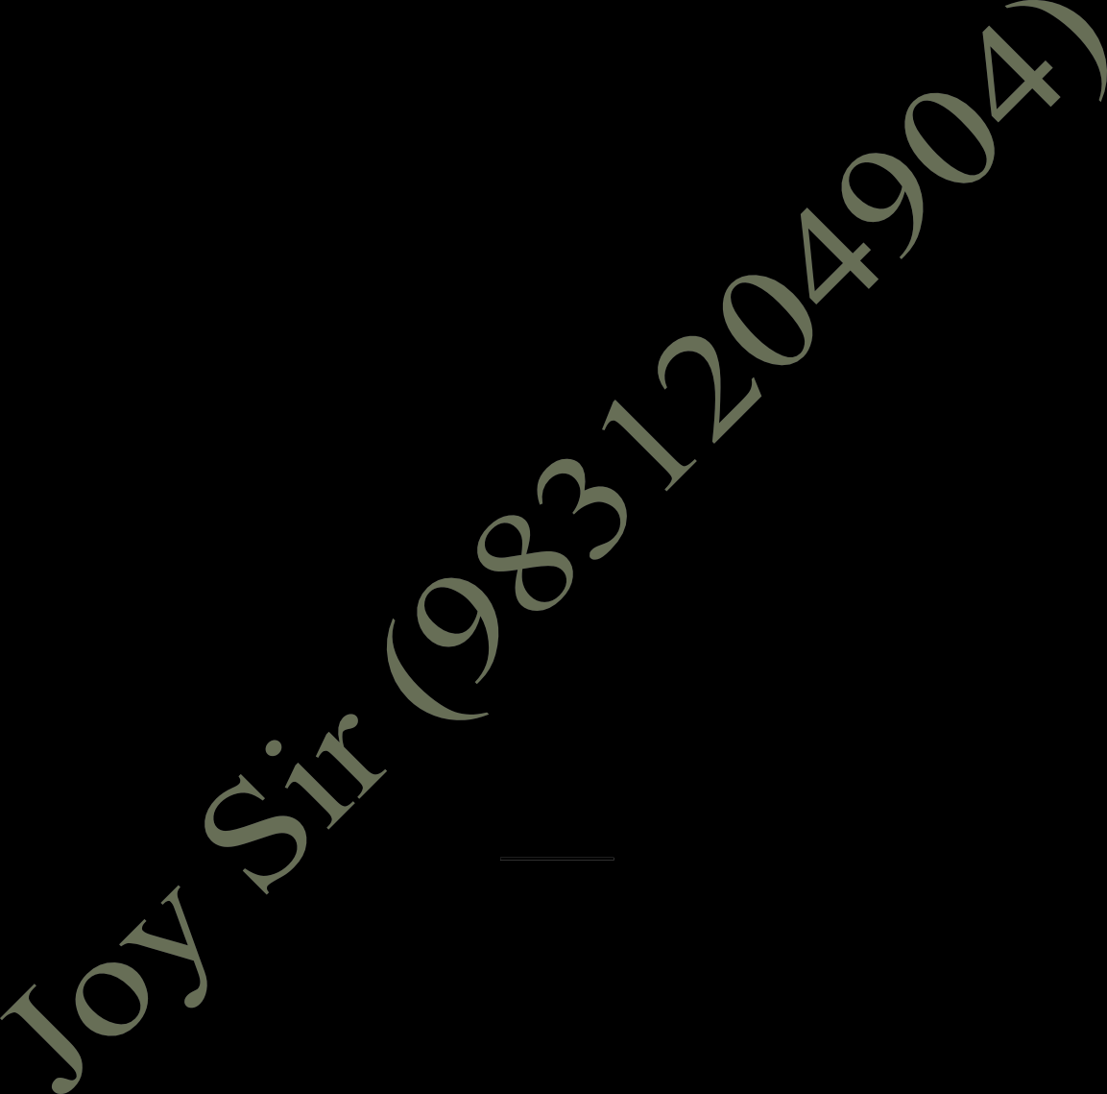

(iv) NEFT and RTGS

[2]

Question 3

(i) Give the meaning of e-marketing.

[2]

(ii) State any two Disadvantages of Internal Recruitment.

[2]

(iii) What is a Budget?

[2]

(iv) Briefly explain any two types of Selection tests.

[2]

Question 4

(i) State any two expectations of suppliers from a business organisation.

[2]

(ii) What is meant by 'Recruitment'?

[2]

(iii) Explain 'Sales Budget.

[2]

(iv) Mention any two objectives of Training.

[2]

**Section B**

*(Answer* ***any four*** *questions from this* ***Section****.)*

Question 5.

(i) Enumerate various types of E-banking facilities.

[5]

1. Suggest any five ways customers benefits from Advertising. [5]
2. Give any five expectations of creditors from a business enterprise. [5]

Question 7.

1. Enumerate any five objectives of training. [5]
2. State any five advantages of Road Transport over Water Transport. [5]

Question 8.

1. Explain any five importance of warehousing. [5]
2. Explain the 'Clearing House Function' of the Central Bank. [5]

Question 9

1. Briefly explain any five demerits of equity shares. [5]
2. Enumerate the advantages and disadvantages of e-tailing. [5]

Question 10

Prepare Trading , Profit and Loss Account , Balance Sheet of M/S Banerjee Enterprise for the year ended 31-03-2010 from the following Trial Balance.[10]

|  |  |  |
| --- | --- | --- |
| Particulars | Amount(Dr) | Amount (Cr) |
| Opening Stock | 25000 |  |
| Purchase | 75000 |  |
| Sales |  | 200000 |
| Discount | 3600 | 6000 |
| Bad Debt | 400 |  |
| Debtors | 32000 |  |
| Creditors |  | 15000 |
| Cash In Hand | 3000 |  |
| Machinery | 50000 |  |
| Salaries | 8000 |  |
| Carriage Inward | 2000 |  |
| Wages | 6000 |  |
| Investment | 20000 |  |
| Land And Building | 90300 |  |
| Bank Overdraft |  | 20360 |
| Commission | 1350 | 3150 |
| Interest On Investment |  | 2000 |
| Electricity | 2000 |  |
| Rent | 2500 |  |
| Insurance | 1800 |  |
| Capital |  | 76440 |
|  | 322950 | 322950 |

Closing Stock was Rs 10,36